-- EXERCISE 2

-- 1. Write the SELECT statement to extract the IDs of employees who are more than 30 years of age.
SELECT EMP_ID
FROM EMPLOYEE_DATA
WHERE AGE > 30;
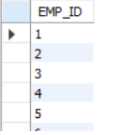
-- 2. Write the SELECT statement to extract the first and last names of all web designers.
SELECT FIRST_NAME, LAST_NAME
FROM EMPLOYEE_DATA
WHERE JOB_TITLE = 'Web Designer';
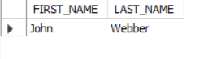
-- 3. What will the following SELECT statement display: SELECT * FROM employee_data WHERE salary <= 1000000?
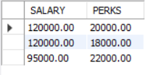
-- THIS WILL DISPLAY ALL COLUMNS (ALL FIELDS) FOR EMPLOYEES WHOSE SALARY IS LESS THAN OR EQUAL TO 1,000,000.
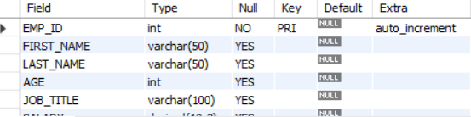

-- 4. How will you display the salaries and perks for employees who have more than $16,000 as perks?
SELECT SALARY, PERKS
FROM EMPLOYEE_DATA
WHERE PERKS > 16000;
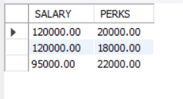

-- 5. List all employee names (last name followed by first name) who hold the title of Marketing Executive.
SELECT CONCAT(LAST_NAME, ', ', FIRST_NAME) AS FULL_NAME
FROM EMPLOYEE_DATA
WHERE JOB_TITLE = 'Marketing Executive';
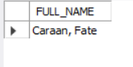
CREATE DATABASE IF NOT EXISTS EXERCISE2_DB;
USE EXERCISE2_DB;
CREATE TABLE EMPLOYEE_DATA (
EMP_ID INT AUTO_INCREMENT PRIMARY KEY,
FIRST_NAME VARCHAR(50),
LAST_NAME VARCHAR(50),
AGE INT,
JOB_TITLE VARCHAR(100),
SALARY DECIMAL(10,2),
PERKS DECIMAL(10,2),
YEARS_OF_SERVICE INT
);
INSERT INTO EMPLOYEE_DATA (FIRST_NAME, LAST_NAME, AGE, JOB_TITLE, SALARY, PERKS, YEARS_OF_SERVICE) VALUES
('Kishey', 'Gacute', 34, 'Programmer', 80000, 4000, 4),
('Kim', 'Ricaro', 33, 'Marketing Executive', 90000, 7000, 3),
('Trisha', 'Ogbac', 35, 'Sales Associate', 85000, 5000, 2),
('Recelle', 'Janda', 45, 'Senior Programmer', 100000, 15000, 5),
('Alessandra', 'Rivano', 34, 'Software Engineer', 90000, 12000, 6),
('Jamaima', 'Rabulan', 35, 'Accountant', 120000, 20000, 7),
('Fate', 'Caraan', 36, 'Marketing Manager', 120000, 18000, 8),
('Mariel', 'Cuenca', 28, 'HR Assistant', 60000, 4000, 2),
('Melody', 'Monreal', 30, 'Marketing Staff', 65000, 3000, 1),
('Mark', 'Pedernal', 27, 'Programmer', 58000, 2000, 2),
('Kim', 'Villareal', 26, 'Sales Representative', 55000, 3500, 2),
('Manuel', 'Santiago', 40, 'Marketing Head', 95000, 22000, 9),
('Alona', 'Navarro', 31, 'Junior Programmer', 75000, 9000, 4);

